**Why an interface material between the CPU and the heatsink?**

The surface of a CPU or a heatsink is never entirely flat; if you place a heatsink directly on a CPU, there will be tiny (invisible) gaps between the two. Since air conducts heat poorly, these gaps have a very negative effect on the heat transfer. Therefore, an interface material with a high thermal conductivity is needed to fill these gaps, and thus improve heat conductivity between CPU and heatsink.   
  
Years ago, when CPU hat power dissipations around 10 watts, a thermal interface material was optional, and most often used by overclockers to improve cooling performance. With todays CPUs, it is an absolute requirement.

**Popular thermal interface materials**

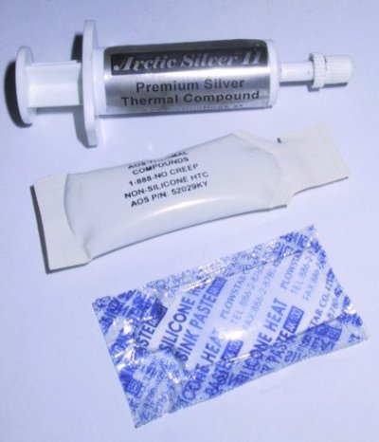  
**Different thermal compounds**   
ArcticSilver II, AOS "HTC" Compound, standard silicone compound

The most commonly used interface material in the electronics cooling area is thermal compound, a sticky paste applied directly on the heatsink or CPU. A good-quality thermal compound will provide the best possible performance. However, the disadvantage of thermal compound is that it is quite messy to handle, and therefore not suitable for mass production.

For this reason, most heatsink manufacturers ship their heatsinks with a "thermal pad", which is supposed to replace thermal compound. The cheapest heatsinks usually come with silver/grey graphite pads. Graphite pads are inexpensive, but provide poor performance (unless a high pressure is applied to the pad, which is not the case when the CPU and heatsink are installed in a regular way). A graphite pad is better than no interface material at all, but if you have the choice, stay away from them.

Today, there are far more advanced thermal pads available, made by companies such as Power Devices, Bergquist or Chomerics, to name only a few. For links to the web sites of these companies, check out the links page. The performance of these pads can be roughly equal to standard thermal compound.

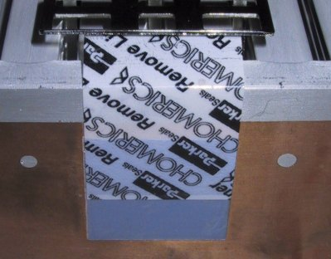  
**Chomerics pad, with its protective foil**   
The foil must be removed before installation

Newer thermal pads are usually made of a phase-change material, which melts to fill all the fine gaps between CPU and heatsink the first time the CPU is heated up. These pads are typically only suitable for one-time installation; if you uninstall the heatsink, e.g. in case of a CPU upgrade, the pad must be removed from the heatsink and replaced by thermal compound. **In no case, a thermal pad *and* thermal compound should be used together**.

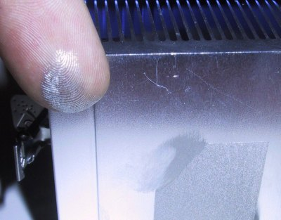  
**A heatsink with preapplied thermal compound**

Some heatsink manufacturers ship their coolers with a thin layer of preapplied thermal compound, protected by a plastic cap. This is good, since it combines the ease of handling of a thermal pad with the good performance of thermal compound. Here too, compound must be reapplied once the heatsink was uninstalled and reinstalled.

If installation time is not an issue, and you are looking to optimize the performance of your cooling system (e.g. for overclocking), the best bet is to purchase a high-quality thermal compound from a specialized retailer.

**Other interface materials**

Self-glueing thermal tape is very convenient for fixing small heatsinks (e.g. for memory chips), but in terms of thermal transfer, it is not as good as thermal compound.

Thermal epoxy is a two-component glue with added substances to improve thermal conductivity. It can also be very convenient for mounting heatsinks; performance is typically better than with self-glueing thermal tape, but not as good as thermal compound.

**How should thermal compound be applied?**

You should apply a very thin (paper thin) layer on the heatsink with your finger before installing it. Don't use too much - *the thinner the layer, the better*. But make sure that the entire contact area between CPU and heatsink is covered; otherwise hot-spots can form.

Then press the heatsink firmly on the CPU. Thermal compound is a very nasty substance, it is sticky and kind of hard to clean off your fingers. It does not conduct electricity, so don't panic if you spill small amounts of it on the CPU's pins. Even silver-based thermal compound has low electrical conductivity, and will not cause short circuits when spilled in small amounts.

Thermal compound normally does not get hard, it will stay sticky for years. But depending on the solvents used in the making of the compound, it may dry over the years. This is not a reason to worry; it will still do its job when dry, and there is no reason to replace dried thermal compound.

**What does it consist of? Is it poisonous?**

Most standard thermal compound consists of silicone. However, silicone doesn't have a high thermal conductivity, so they also contains zinc oxide to improve this. The zinc oxide also explains its white colour.

High-End thermal compounds are usually silicone-free, and use metal-based additives (e.g. aluminum oxide or nitride, or even pulverized silver!) instead of Zinc Oxide.

I have heard people saying that heat sink compound contained heavy metals and was poisonous. Neither silicone nor zinc oxide are poisonous However, especially with advanced thermal compounds, other ingredients may have been used, and are usually not declared. But despite strict laws on marking poisonous substances in Europe and the US, I have never seen a thermal compound that was marked as poisonous. Still, use common sense, and don't confuse it with tooth paste.

**Where to buy it?**

Standard (silicone based) compound can be bought at almost any electronics store, including Radio Shack (Cat. No.: 276-1372). The price is in the $2 range. Two grammes should suffice for installing many many heatsinks. High end thermal compounds, with even better thermal conductivities, are available from specialized heatsink retailers; see the "Links" section for details. In the overclocking scene, the [ArcticSilver](http://www.arcticsilver.com/) thermal compound is very popular; it is expensive, but provides excellent performance.

**Performance of thermal compound**

The performance of thermal compound is measured in W/mK. Standard silicon/zinc oxide thermal compound has thermal conductivities between 0.7 and 0.9 W/mK, high end compound can have thermal conductivities of around 2 - 3 W/mK or more. But not only the thermal conductivity matters. The compound should also be very smooth - if it is too grainy or too hard, then it is hard to apply a really thin layer.

**Why does my CPU get *hotter* after I used thermal compound?**

It doesn't - in no case your CPU get hotter after you applied thermal compound. However, you might *think* that it gets hotter, because the heatsink gets hotter. A hotter heatsink means better thermal conductivity between the CPU and the heatsink. The CPU itself will be cooler.

**Also know as?**

"heat sink jelly", "heatsink compound", "thermal compound", "thermal goo", "silicon compound".

**A more scientific approach to thermal compound...**

If the information here did not go enough into detail for your needs, visit <http://www.electronics-cooling.com/Resources/EC_Articles/SEP96/sep96_01.htm>. You'll find more scientific information about thermal compound and related topics.